

# Statement and Confirmation of Own Work

Programme/Qualification name:

*All NCC Education assessed assignments submitted by students must have this statement as the cover page or it will not be accepted for marking. Please ensure that this statement is either firmly attached to the cover of the assignment or electronically inserted into the front of the assignment.*

**Student declaration**

I have read and understood NCC Education’s Policy on Academic Dishonesty and Plagiarism.

I can confirm the following details:

Student ID/Registration number: 00170340

Name: Samuel Mwaura Karanja

Centre Name: COMPUTER PRIDE LIMITED

**Module Name:** **Dynamic Websites**

Module Leader: Mr. Dennis

Number of words:

I confirm that this is my own work and that I have not plagiarised any part of it. I have also noted the assessment criteria and pass mark for assignments.

Due Date: 17/10/2022

**Submitted Date: 17/10/2022**

**Signature:**

|  |
| --- |
| **TABLE OF CONTENTS**  **Statement And Confirmation Of Own Work……………………………......1**  **Introduction……………………………………………………………………3**  **HTML……………………………………………………………………….....4**  **CSS………………………………………………………………………..........11**  **Reflection............................................................................................................41**  **References……………………………………………………………………..,41** |

**HOME GYM EQUIPMENT**

**Documentation**

A Web application is an application program stored in a remote server and delivered over the internet via a browser interface. An example of a web application is an ecommerce website where customers can purchase items over the internet and make payments.

This would be perfect for Home Gym equipment as they would make sales via the internet, because web applications allow multiple users to access the same version of an application, plus web apps do not have to be installed. Users can access this website over any device which makes Home Gym Equipment very dynamic.

HTML is used to design the header, body and footer of the website pages. The header contains the company logo, company name and the navigation bar to the other website pages of Home Gym Equipment Website. The header also contains a register button that redirects the user to a registration page where they fill in their details in a provided registration form. In some of the pages there is a search bar where users can search for specific products.

In the body section, it includes information about Home Gym Website and exciting pictures with details about them, while in other pages there are forms that pick the user details and store them in a database.

In the footer section we have a newsletter input section with a subscribe button, and navigational links to some of our web pages, with exciting icons to our social media pages.

Finally there is a copyright information at the bottom of the page.

**HTML**

The design of the website is purely by HTML. The website has 10 interlinked pages

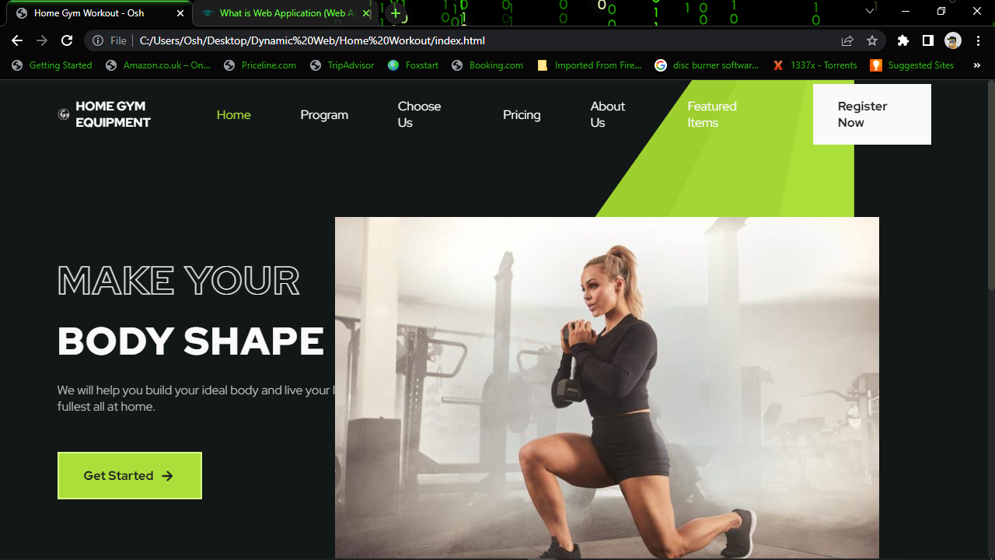

**This is the company Homepage**

The User is welcomed by interesting visuals, minimal text, and a button that prompts the user to register on the website.

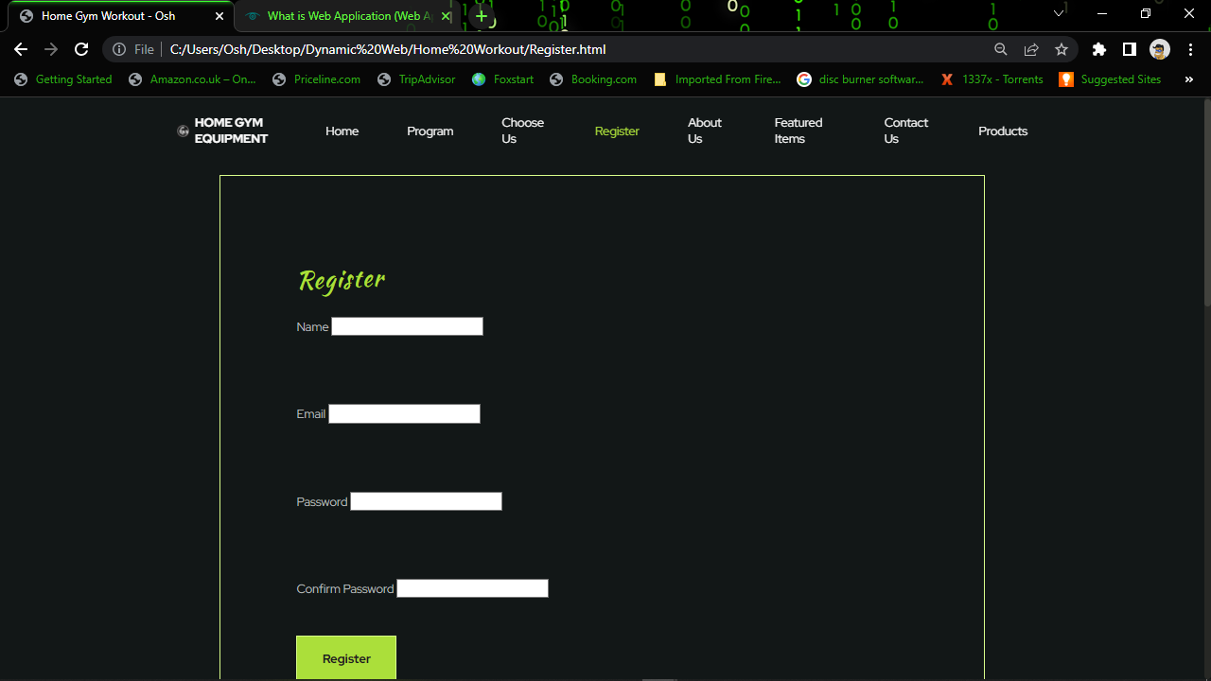

The button navigates to the registration page where the user fills in their details and hits the register button.

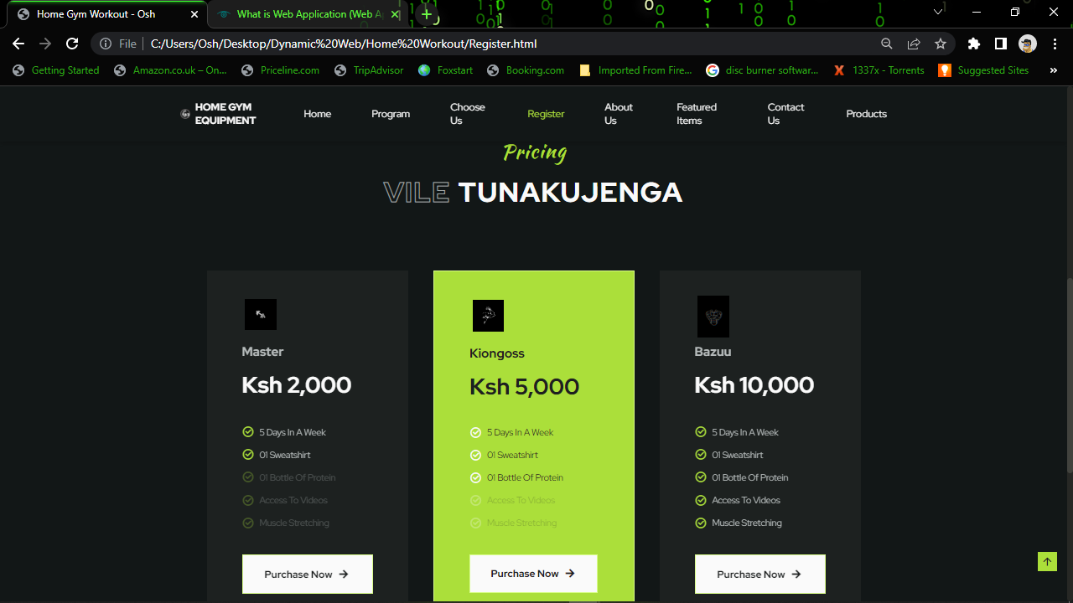

The page also includes interesting packages that the user can choose from after registering

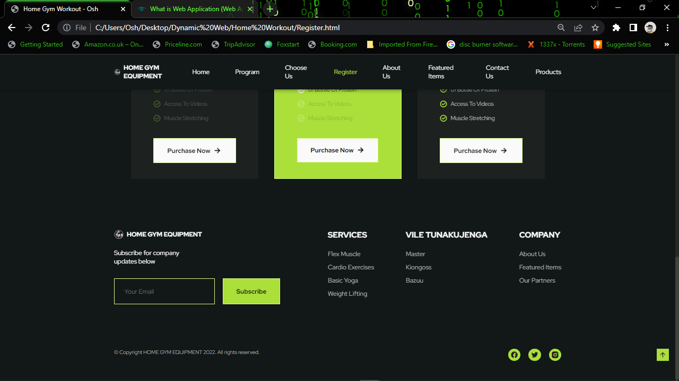

At the footer there are links to Home Gym Equipments services and icons to their social media pages.

Clicking on the company logo navigates back to the home page.

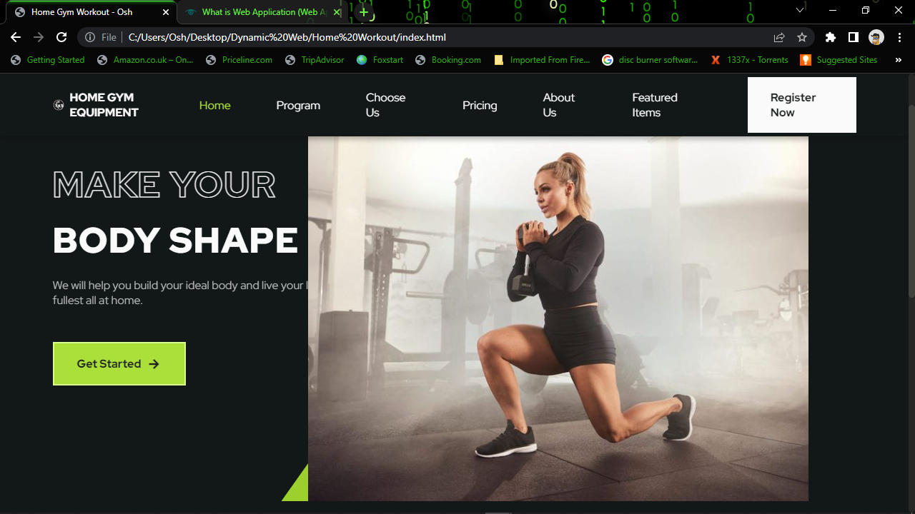

The Get Started button navigates to the our program page with interesting information cards.

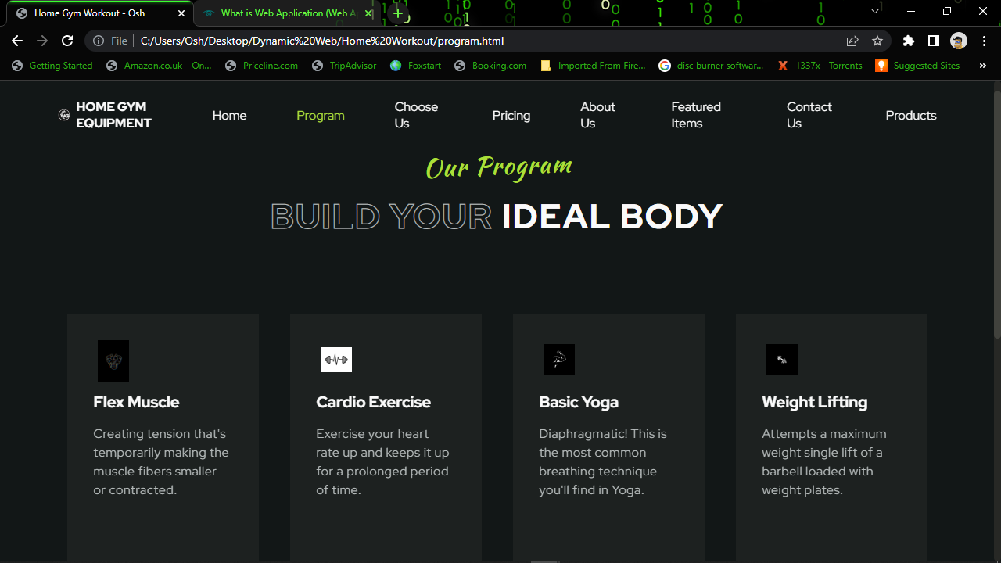

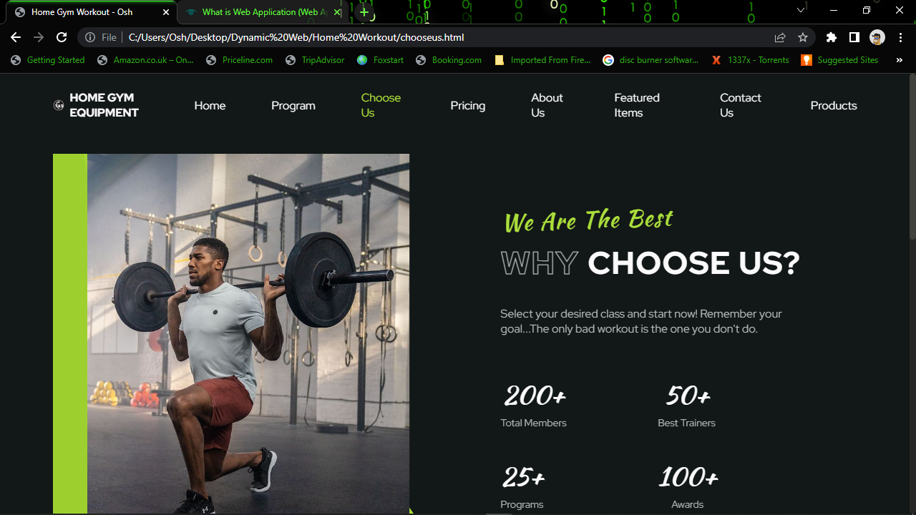

The choose us page provides further information

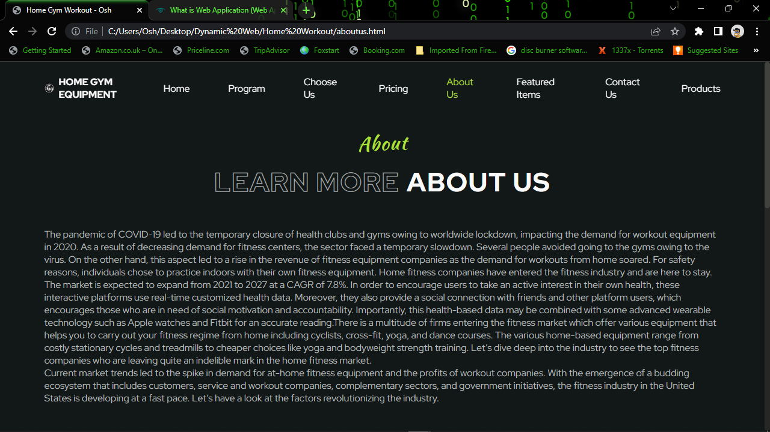

And so does the About us page

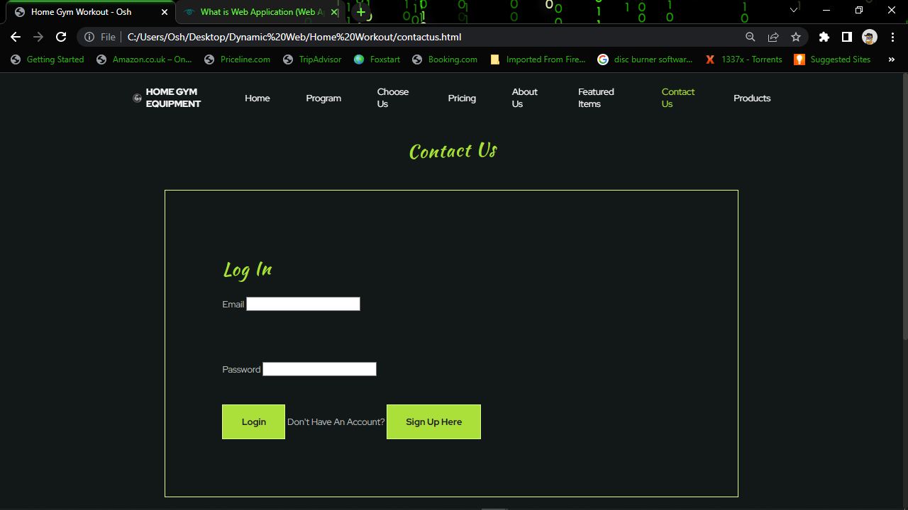

The contact us page provides a form for the user to log in into their account.

If the user doesn’t have an account the sign up here button navigates to the register page.

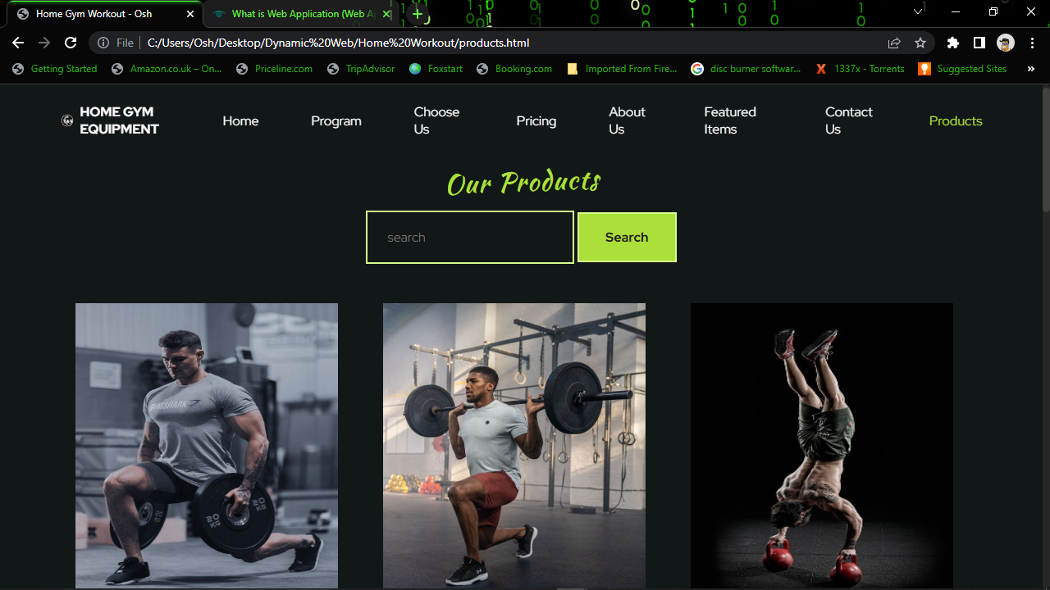

There is a products page displaying a variety of products and a search bar where users can search for products.

There is also a hover effect on the products that transforms the images when hovered on.

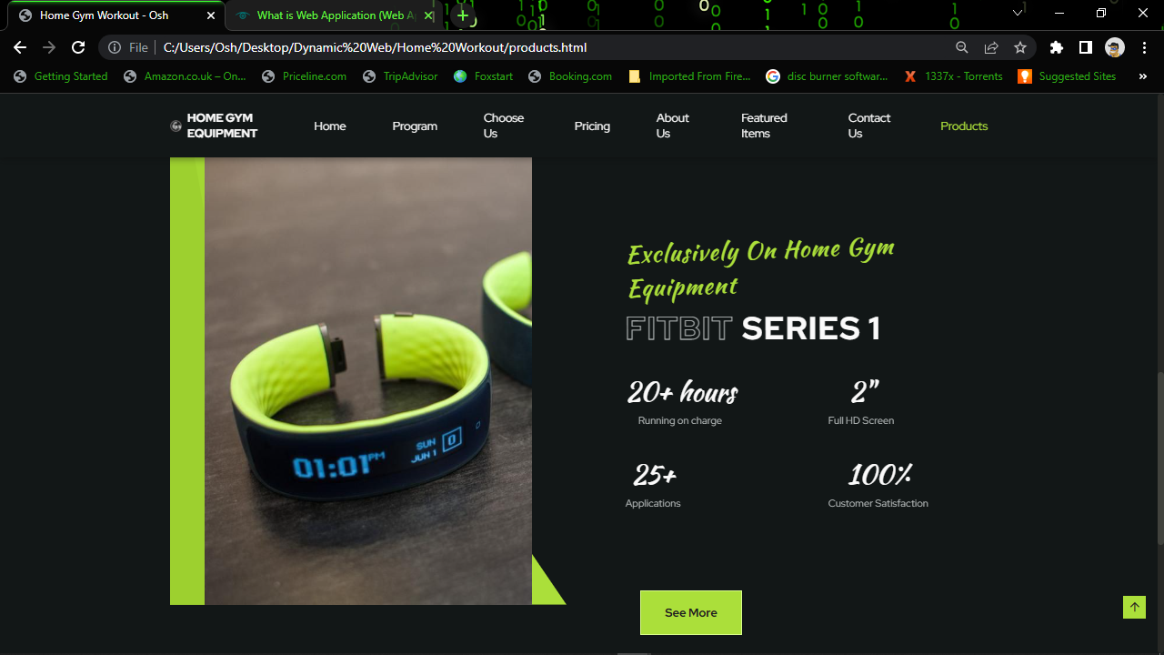

There is also an exclusive wearable technology product section in the page, with additional information on the product. The button navigates to the product’s category called wearable technology with a range of products on the same category

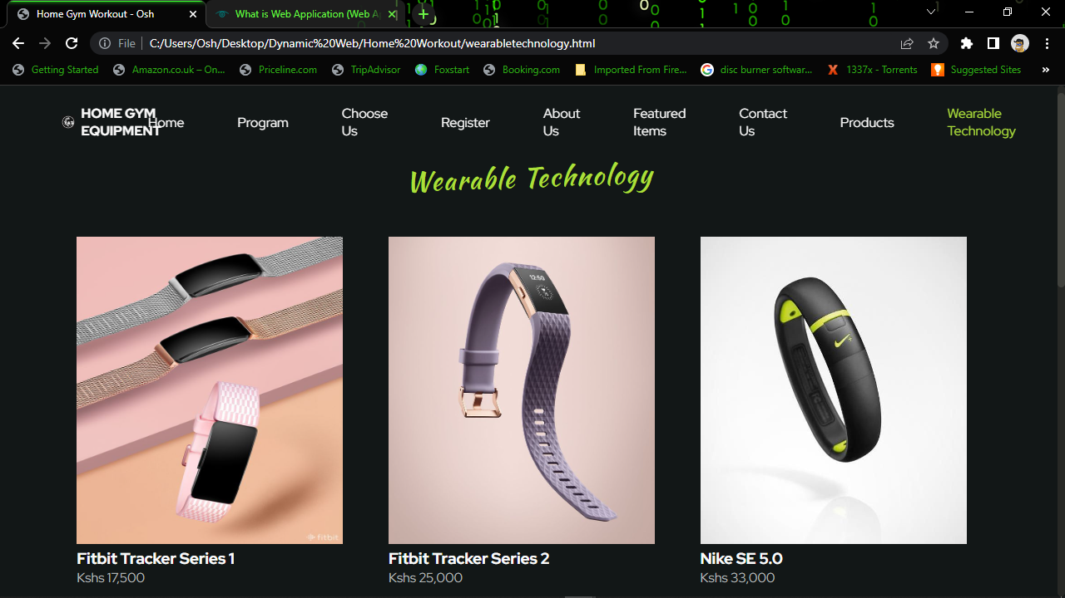

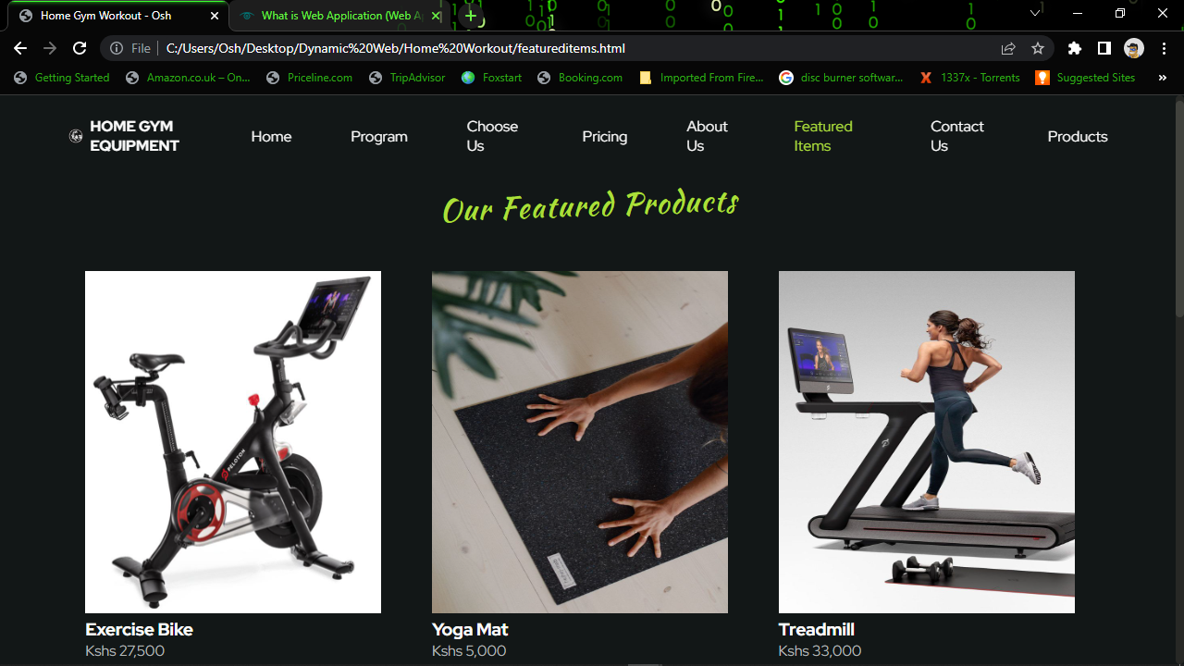

There is a featured products page with a range of products.

**CSS**

CSS is used to style the elements in the website, by standardizing the images, text, input sections and buttons.

/*---------------------FONTS-----------------*/

@import url('https://fonts.googleapis.com/css2?family=Kaushan+Script&family=Red+Hat+Display:wght@400;700;900&display=swap');

/*-----------------------VARIABLES CSS--------------------*/

:root {

--header-height: 3.5rem;

/*----------COLORS----------*/

--first-color: hsl(79, 72%, 55%);

--first-color-light: hsl(79, 97%, 77%);

--first-color-alt: hsl(79, 67%, 52%);

--first-color-dark: hsl(79, 63%, 50%);

--first-color-gray: hsl(79. 6%, 64%);

--title-color: hsl(180, 4%, 98%);

--title-color-black: hsl(180, 4%, 12%);

--text-color: hsl(180, 4%, 72%);

--text-color-light: hsl(180, 4%, 65%);

--body-color: hsl(180, 12%, 8%);

/*---------------FONT AND TYPOGRAPHY---------*/

--body-font: 'Red Hat Display', sans-serif;

--second-font: 'Kaushan Script', cursive;

--biggest-font-size: 2rem;

--bigger-font-size: 1.5rem;

--big-font-size: 1.25rem;

--h1-font-size: 1.5rem;

--h2-font-size: 1.25rem;

--h3-font-size: 1rem;

--normal-font-size: .938rem;

--small-font-size: .813rem;

/*----------FONT WEIGHT-----------*/

--font-bold: 700;

--font-black: 900;

/*-----------Z INDEX-----------*/

--z-tooltip: 10;

--z-fixed: 100;

}

/*---------------RESPONSIVE TYPOGRAPHY---------------*/

@media screen and (min-width: 1024px) {

    :root{

        --biggest-font-size: 6rem;

        --bigger-font-size: 3.5rem;

        --big-font-size: 2.75rem;

        --h1-font-size: 2.25rem;

        --h2-font-size: 1.5rem;

        --h3-font-size: 1.25rem;

        --normal-font-size: 1rem;

        --small-font-size: .875rem;

        --smaller-font-size: .813rem;

    }

}

/*-------------BASE--------------*/

*{

    box-sizing: border-box;

    padding: 0;

    margin: 0;

}

html{

    scroll-behavior: smooth;

}

body,

button,

input{

    font-family: var(--body-font);

    font-size: var(--normal-font-size);

}

body{

    background-color: var(--body-color);

    color: var(--text-color);

}

h1,

h2,

h3{

    color: var(--title-color);

    font-weight: var(--font-bold);

}

ul{

    list-style: none;

}

a{

    text-decoration: none;

}

img{

    max-width: 100%;

    height: auto;

}

/*---------------REUSABLE CSS CLASSES----------------*/

.container{

    max-width: 1124px;

    margin-right: 1.5rem;

    margin-left: 1.5rem;

}

.section{

    padding: 4.5rem 0 2rem;

}

.section__data{

    display: flex;

    flex-direction: column;

    row-gap: 0.75rem;

    text-align: center;

    margin-bottom: 3rem;

}

.section__title,

.section__title-border{

    font-size: var(--big-font-size);

    letter-spacing: 1.5px;

}

.section__subtitle{

    font-size: var(--h2-font-size);

    font-family: var(--second-font);

    font-weight: 400;

    letter-spacing: 1.5px;

    color: var(--first-color);

    transform: rotate(-2deg);

}

.section__titles{

    display: flex;

    column-gap: .75rem;

    justify-content: center;

}

.section__title-border{

    -webkit-text-stroke: 1px var(--text-color);

    color: transparent;

}

.grid{

    display: grid;

    gap: 1.5rem;

}

.main{

    overflow: hidden; /*for animation scroll reveal*/

}

.color-red{

    color: hsl(0, 80%, 64%);

}

.color-green{

    color: var(--first-color);

}

/*------------------HEADER AND NAV------------------*/

.header{

    width: 100%;

    background-color: transparent;

    position: fixed;

    top: 0;

    left: 0;

    z-index: var(--z-fixed);

    transition: background .3s;

}

.nav{

    height: var(--header-height);

    display: flex;

    justify-content: space-between;

    align-items: center;

}

.nav__logo,

.nav__toggle{

    color: var(--title-color);

    display: flex;

}

.nav__logo{

    align-items: center;

    column-gap: .5rem;

    font-weight: var(--font-bold);

}

.nav__logo img{

    width: 1rem;

}

.nav__toggle{

    font-size: 1.25rem;

    cursor: pointer;

}

@media screen and (max-width: 1023px){

    .nav__menu{

        position: fixed;

        background-color: hsla(180, 12%, 8%, .8);

        backdrop-filter: blur(32px);

        -webkit-backdrop-filter: blur(32px);

        top: 0;

        right: -100%;

        width: 100%;

        height: 100%;

        border-left: 2px solid var(--first-color-gray);

        transition: right .3s;

    }

}

.nav__list{

    padding: 5rem 0 0 3rem;

    display: flex;

    flex-direction: column;

    row-gap: 2.5rem;

}

.nav__link{

    color: var(--title-color);

    transition: color .3s;

}

.nav__link:hover{

    color: var(--first-color);

}

.nav__close{

    position: absolute;

    top: 1rem;

    right: 1.5rem;

    font-size: 1.5rem;

    color: var(--title-color);

    cursor: pointer;

}

.nav .nav__button{

    background-color: var(--title-color);

    border: none;

}

/*SHOW MENU*/

.show-menu{

    right: 0;

}

/*CHANGE BACKGROUND HEADER*/

.bg-header{

    background-color: var(--body-color);

    box-shadow: 0 4px 8px hsla(180, 12%, 4%, .3);

}

/*ACTIVE LINK*/

.active-link{

    color: var(--first-color);

}

/*--------------------------------HOME----------------------------*/

.home{

    position: relative;

    padding-bottom: 0;

}

.home__container{

    padding-top: 4rem;

    row-gap: 3rem;

}

.home__data{

    text-align: center;

}

.home__subtitle{

    font-size: var(--bigger-font-size);

    -webkit-text-stroke: 1px var(--title-color);

    color: transparent;

}

.home__title{

    font-size: var(--biggest-font-size);

    font-weight: var(--font-black);

    margin: .5rem 0;

}

.home__subtitle,

.home__title{

    letter-spacing: 1.5px;

    font-size: 50px;

}

.home__description{

    margin-bottom: 2.5rem;

}

.home__triangle{

    height: 325px;

    position: absolute;

    right: 0;

    bottom: 0;

    clip-path: polygon(100% 0, 0 100%, 100% 100%);

}

.home__triangle-1{

    width: 105px;

    background-color: var(--first-color);

}

.home__triangle-2{

    width: 205px;

    background-color: var(--first-color-alt);

}

.home__triangle-3{

    width: 305px;

    background-color: var(--first-color-dark);

}

.home__img{

    display: flex;

    position: relative;

    z-index: 1;

    width: 250px;

    margin: 0 auto;

}

/*------------------BUTTON---------------------*/

.button{

    display: inline-block;

    background-color: var(--first-color);

    padding: 18px 32px;

    border: 2px solid var(--first-color-light);

    color: var(--title-color-black);

    font-weight: var(--font-bold);

    cursor: pointer;

    transition: background .3s;

}

.button:hover{

    background-color: var(--first-color-alt);

}

.button i{

    font-size: 1.25rem;

    transition: transform .3s;

}

.button__flex{

    display: inline-flex;

    align-items: center;

    justify-content: center;

    column-gap: .5rem;

}

.button__flex:hover i{

    transform: translateX(.25rem);

}

/*-----------------------SPONSORS-------------------*/

.logos__container{

    grid-template-columns: repeat(2, 1fr);

    gap: 2rem;

    justify-items: center;

}

.logos__img{

    width: 120px;

    height: 120px;

}

/*--------------------PROGRAM---------------------*/

.program__container{

    grid-template-columns: 225px;

    justify-content: center;

    row-gap: 2rem;

}

.program__card{

    display: grid;

    background-color: hsla(79, 6%, 64%, .07);

    padding: 1.5rem 2rem;

    border: 2px solid transparent;

    transition: background .5s, border .4s;

}

.program__img{

    width: 40px;

}

.program__shape{

    width: 50px;

    height: 50px;

    background-color: var(--first-color-gray);

    border-radius: 50%;

    display: grid;

    place-items: center;

    margin-bottom: 1rem;

    transition: background .5s;

}

.program__title{

    font-size: var(--h3-font-size);

    margin-bottom: 1rem;

}

.program__description{

    font-size: var(--small-font-size);

    letter-spacing: .5px;

    line-height: 150%;

}

.program__title,

.program__description{

    transition: color .5s;

}

.program__button{

    justify-self: flex-end;

    margin-top: 1.5rem;

    font-size: 1.25rem;

    color: var(--title-color-black);

    opacity: 0;

    transition: opacity .4s;

}

.program__button i{

    display: block;

    transition: transform .3s;

}

.program__button:hover i{

    transform: translateX(.25rem);

}

.program__card:hover{

    background-color: var(--first-color);

    border: 2px solid var(--first-color-light);

}

.program__card:hover .program__shape{

    background-color: var(--first-color-light);

}

.program__card:hover .program__title,

.program__card:hover .program__description{

    color: var(--title-color-black);

}

.program__card:hover .program__button{

    opacity: 1;

}

/*----------------------CHOOSE US------------------*/

.choose{

    padding-bottom: 0;

}

.choose__overflow{

    position: relative;

}

.choose__container{

    row-gap: 3rem;

}

.choose__content .section__data{

    margin-bottom: 2rem;

}

.choose__description{

    text-align: center;

    margin-bottom: 2.5rem;

}

.choose__data{

    display: grid;

    grid-template-columns: repeat(2, 1fr);

    row-gap: 2rem;

}

.choose__group{

    text-align: center;

}

.choose__number{

    font-size: var(--h1-font-size);

    font-family: var(--second-font);

    font-weight: 400;

    margin-bottom: .25rem;

}

.choose__subtitle{

    font-size: var(--small-font-size);

}

.choose__triangle{

    height: 325px;

    position: absolute;

    left: 0;

    bottom: 0;

    clip-path: polygon(0 0, 0 100%, 100% 100%);

}

.choose__triangle-1{

    width: 305px;

    background-color: var(--first-color);

}

.choose__triangle-2{

    width: 205px;

    background-color: var(--first-color-alt);

}

.choose__triangle-3{

    width: 105px;

    background-color: var(--first-color-dark);

}

.choose__img{

    width: 470px;

    display: block;

    position: relative;

    z-index: 1;

    margin: 0 auto;

}

/*----------------------WEARABLE TECHNOLOGY----------------------*/

.technology__button{

    display: inline-block;

    background-color: var(--first-color);

    padding: 18px 32px;

    border: 2px solid var(--first-color-light);

    color: var(--title-color-black);

    font-weight: var(--font-bold);

    cursor: pointer;

    transition: background .3s;

    margin-top: -70px;

    margin-left: 880px;

}

.technology__button:hover{

    background-color: var(--first-color-alt);

}

.technology__button i{

    font-size: 1.25rem;

    transition: transform .3s;

}

.technology__button__flex{

    display: inline-flex;

    align-items: center;

    justify-content: center;

    column-gap: .5rem;

}

.technology__button__flex:hover i{

    transform: translateX(.25rem);

}

/*----------------------PRICING----------------------*/

.pricing__container{

    grid-template-columns: 285px;

    justify-content: center;

    row-gap: 2 rem;

}

.pricing__card,

.pricing__shape,

.pricing__list{

    display: grid;

}

.pricing__card{

    row-gap: 2rem;

    background-color: hsla(79, 6%, 64%, .07);

    padding: 2rem 2.5rem;

}

.pricing__img{

    width: 50px;

}

.pricing__shape{

    width: 60px;

    height: 60px;

    background-color: var(--first-color-gray);

    border-radius: 50%;

    place-items: center;

    margin-bottom: 1rem;

}

.pricing__title{

    font-size: var(--h3-font-size);

    color: var(--text-color);

    margin-bottom: 1rem;

}

.pricing__number{

    font-size: var(--h1-font-size);

}

.pricing__list{

    row-gap: 1rem;

}

.pricing__item{

    display: flex;

    column-gap: .5rem;

    align-items: center;

    font-size: var(--small-font-size);

}

.pricing__item i{

    font-size: 1.25rem;

    color: var(--first-color);

}

.pricing__item-opacity{

    opacity: .3;

}

.pricing__button{

    background-color: var(--title-color);

}

.program__button:hover{

    background-color: var(--title-color);

}

.pricing__card-active{

    background-color: var(--first-color);

    border: 2px solid var(--first-color-light);

}

,.pricing__card-active .pricing__shape{

    background-color: var(--first-color-light);

}

.pricing__card-active .pricing__item i{

    color: var(--title-color);

}

.pricing__card-active .pricing__title,

.pricing__card-active .pricing__number,

.pricing__card-active .pricing__item{

    color: var(--title-color-black);

}

/*-------------------PRODUCTS--------------------*/

.col-3{

    flex-basis: 30%;

    min-width: 250px;

    margin-bottom: 30px;

}

.col-3 img{

    height: 370px;

    width: 320px;

}

.row{

    display: flex;

    align-items: center;

    flex-wrap: wrap;

    justify-content: space-around;

}

.col-3:hover{

    transform: translateY(-8px);

    cursor: pointer;

}

.search__form{

    float: right;

}

/*--------------------ABOUT----------------------=*/

.about__container{

    grid-template-columns: 450px;

    justify-content: space-around;

    row-gap: 2rem;

    width: 60rem;

    display: flex;

    align-items: center;

    margin-top: 100px;

}

.about__card{

    display: grid;

    background-color: hsla(79, 6%, 64%, .07);

    padding: 1.5rem 2rem;

    border: 2px solid transparent;

    transition: background .5s, border .4s;

}

.about__img{

    width: 40px;

}

.about__shape{

    width: 70px;

    height: 70px;

    background-color: var(--first-color-gray);

    border-radius: 50%;

    display: grid;

    place-items: center;

    margin-bottom: 1rem;

    transition: background .5s;

}

.about__title{

    font-size: var(--h3-font-size);

    margin-bottom: 1rem;

}

.about__description{

    font-size: var(--small-font-size);

    letter-spacing: .5px;

    line-height: 150%;

}

.about__title,

.about__description{

    transition: color .5s;

}

.about__button{

    justify-self: flex-end;

    margin-top: 1.5rem;

    font-size: 1.25rem;

    color: var(--title-color-black);

    opacity: 0;

    transition: opacity .4s;

}

.about__button i{

    display: block;

    transition: transform .3s;

}

.about__button:hover i{

    transform: translateX(.25rem);

}

.about__card:hover{

    background-color: var(--first-color);

    border: 2px solid var(--first-color-light);

}

.about__card:hover .about__shape{

    background-color: var(--first-color-light);

}

.about__card:hover .about__title,

.about__card:hover .about__description{

    color: var(--title-color-black);

}

.about__card:hover .about__button{

    opacity: 1;

}

/*--------------------CALCULATE-------------------*/

.calculate{

    padding-bottom: 0;

}

.calculate__container{

    row-gap: 4rem;

}

.calculate__content .section__titles{

    margin-bottom: 2rem;

    text-align: center;

}

.calculate__description{

    text-align: center;

    margin-bottom: 2.5rem;

}

.calculate__form{

    display: grid;

    row-gap: 1rem;

}

.calculate__box{

    position: relative;

    border: 2px solid var(--first-color-light);

}

.calculate__input{

    width: 100%;

    background: transparent;

    padding: 20px 56px 20px 24px;

    outline: none;

    border: none;

    color: var(--text-color);

}

.calculate__input ::-webkit-outer-spin-button,

.calculate__input ::-webkit-inner-spin-button{

    -webkit-appearance: none;

    margin: 0;

}

.calculate__input[type=number]{

    -moz-appearance: textfield;

}

.calculate__label{

    position: absolute;

    right: 1.5rem;

    top: 1.25rem;

    color: var(--title-color);

}

.calculate__form .button{

    margin-top: 1.5rem;

}

.calculate__img{

    width: 300px;

    justify-self: center;

}

.calculate__message{

    position: absolute;

    transform: translateY(1rem);

}

/*---------------LOG IN--------------*/

#login{

    display: block;

    padding: 100px;

    margin: 0 auto;

    width: 90%;

    border: 2px solid var(--first-color-light);

}

.login_button{

        display: inline-block;

        background-color: var(--first-color);

        padding: 18px 32px;

        border: 2px solid var(--first-color-light);

        color: var(--title-color-black);

        font-weight: var(--font-bold);

        cursor: pointer;

        transition: background .3s;

    }

    .button:hover{

        background-color: var(--first-color-alt);

    }

.form-control{

    margin-bottom: 50px;

    padding-right: 30px;

    margin-top: 40px;

}

/*---------------FOOTER--------------*/

.footer__container{

    row-gap: 4rem;

    padding-top: 1rem;

}

.footer__logo,

.footer__description{

    color: var(--title-color);

}

.footer__logo,

.footer__form,

.footer__social{

    display: flex;

}

.footer__logo{

    align-items: center;

    column-gap: .5rem;

    font-weight: var(--font-bold);

    margin-bottom: 1.5rem;

}

.footer__logo img{

    width: 1.5rem;

}

.footer__description{

    margin-bottom: 2rem;

}

.footer__form{

    flex-direction: column;

    gap: 1.25rem;

}

.footer__input{

    padding: 20px 56px 20px 24px;

    border: 2px solid var(--first-color-light);

    background: transparent;

    color: var(--text-color);

    outline: none;

}

.footer__content,

.footer__links,

.footer__group{

    display: grid;

}

.footer__content{

    grid-template-columns: repeat(2,max-content);

    gap: 2.5rem 3.5rem;

}

.footer__title{

    font-size: var(--h3-font-size);

    margin-bottom: 1.5rem;

}

.footer__links{

    row-gap: .75rem;

}

.footer__link{

    color: var(--text-color);

    transition: color .3s;

}

.footer__link:hover{

    color: var(--first-color);

}

.footer__group{

    margin-top: 5rem;

    justify-items: center;

    row-gap: 2rem;

}

.footer__social{

    column-gap: 1.25rem;

}

.footer__social-link{

    display: inline-flex;

    padding: .35rem;

    background-color: var(--first-color);

    border-radius: 50%;

    font-size: 1.25rem;

    color: var(--title-color-black);

    transition: background .4s;

}

.footer__social-link:hover{

    background-color: var(--first-color-dark);

}

.footer__copy{

    font-size: var(--smaller-font-size);

    color: var(--text-color-light);

}

.footer__message{

    position: absolute;

    transform: translateY(1rem);

}

/*-----------------SCROLL BAR-------------------*/

::-webkit-scrollbar{

    width: .6rem;

    border-radius: .5rem;

    background-color: hsl(79, 4%, 15%);

}

::-webkit-scrollbar-thumb{

    background-color: hsl(79, 4%, 25%);

    border-radius: .5rem;

}

::-webkit-scrollbar-thumb:hover{

    background-color: hsl(79, 4%, 35%);

}

/*----------------SCROLL UP-----------------*/

.scrollup{

    position: fixed;

    right: 1rem;

    bottom: -30%;

    background-color: var(--first-color);

    display: inline-flex;

    padding: .35rem;

    color: var(--title-color-black);

    font-size: 1.25rem;

    z-index: var(--z-tooltip);

    transition: .3s;

}

.scrollup:hover{

    transform: translateY(-.25rem);

}

/*show scroll up*/

.show-scroll{

bottom: 3rem;

}

/*----------BREAKPOINTS----------*/

/* For Small Devices*/

@media screen and (max-width: 340px){

    .container{

        margin-left: 1rem;

        margin-right: 1rem;

    }

    .section__titles{

        flex-direction: column;

        row-gap: .25rem;

    }

    .home__triangle,

    .choose__triangle{

        height: 255px;

    }

    .choose__triangle-3,

    .choose__triangle-1{

        width: 260px;

    }

    .choose__img{

        width: 195px;

    }

    .pricing__container{

        grid-template-columns: 250px;

    }

    .pricing__card{

        padding: 1.5rem;

    }

    .footer__content{

        grid-template-columns: 1fr;

    }

}

/* For Medium Devices*/

@media screen and (min-width: 768px){

    .nav__menu{

        width: 50%;

    }

    .home__container,

    .choose__container{

        grid-template-columns: repeat(2, 1fr);

        align-items: center;

    }

    .home__data,

    .choose__content .section__data,

    .choose__description,

    .calculate__description{

        text-align: initial;

    }

    .logos__container{

        grid-template-columns: repeat(4, 1fr);

    }

    .program__container{

        grid-template-columns: repeat(2, 225px);

        gap: 2.5rem;

    }

    .choose__content{

        order: 1;

    }

    .choose__data{

        justify-items: flex-start;

    }

    .choose__content .section__titles,

    .calculate__content .section__titles{

        justify-content: initial;

    }

    .pricing__container{

        grid-template-columns: repeat(2, 285px);

        gap: 2.5rem;

    }

    .calculate__container{

        grid-template-columns: 1fr .8fr;

        align-items: center;

    }

    .calculate__form{

        grid-template-columns: repeat(1, 1fr);

        column-gap: 1.5rem;

    }

    .calculate__form .button{

        grid-column: 1 / 3;

    }

    .footer__container{

        grid-template-columns: repeat(2, max-content);

        justify-content: space-between;

    }

    .footer__content{

        grid-template-columns: repeat(3, max-content);

    }

}

/* For Large Devices*/

@media screen and (min-width: 1023px){

    .nav{

        height: calc(var(--header-height) + 2rem);

    }

    .nav__menu{

        width: initial;

    }

    .nav__toggle,

    .nav__close{

        display: none;

    }

    .nav__list{

        flex-direction: row;

        padding: 0;

        align-items: center;

        column-gap: 4rem;

    }

    .section{

        padding: 7rem 0 0;

    }

    .section__subtitle{

        font-size: 2rem;

    }

    .home__container{

        grid-template-columns: repeat(2, max-content);

        align-items: initial;

    }

    .home__title{

        margin: .75rem 0 1.25rem;

    }

    .home__description{

        width: 445px;

        margin-bottom: 3rem;

    }

    .home__img{

        width: 570px;

        transform: translateX(-6rem);

    }

    .home__triangle{

        height: 700px;

    }

    .home__triangle-1{

        width: 145px;

    }

    .home__triangle-2{

        width: 345px;

    }

    .home__triangle-3{

        width: 545px;

    }

    .logos{

        padding: 3.5rem 0 1rem;

    }

    .logos__img{

        width: 190px;

    }

    .choose__overflow{

        overflow: hidden;

    }

    .choose__img{

        width: 350px;

    }

    .choose__triangle{

        height: 700px;

    }

    .choose__triangle-1{

        width: 545px;

    }

    .choose__triangle-2{

        width: 345px;

    }

    .choose__triangle-3{

        width: 145px;

    }

    .footer{

        padding-bottom: 3rem;

    }

    .footer__form{

        flex-direction: row;

    }

    .footer__content{

        column-gap: 5rem;

    }

    .footer__group{

        grid-template-columns: repeat(2, max-content);

        justify-content: space-between;

        margin-top: 7rem;

    }

    .footer__social{

        order: 1;

    }

}

@media screen and (min-width: 1150px){

    .container{

        margin-left: auto;

        margin-right: auto;

    }

    .home__data{

        padding-top: 3rem;

    }

    .home__images{

        transform: translateX(-9rem);

    }

    .home__img{

        width: 700px;

        transform: translateX(2rem);

    }

    .home__triangle{

        height: 995px;

    }

    .home__triangle-1{

        width: 205px;

    }

    .home__triangle-2{

        width: 505px;

    }

    .home__triangle-3{

        width: 705px;

    }

    .program__container{

        grid-template-columns: repeat(4, 245px);

        padding: 3rem 0;

    }

    .program__card{

        padding: 2rem;

    }

    .program__description{

        font-size: var(--normal-font-size);

    }

    .choose__container{

        column-gap: 8rem;

    }

    .choose__img{

        width: 450px;

        margin: 0 0 0 auto;

    }

    .choose__triangle{

        height: 800px;

    }

    .choose__images{

        position: relative;

    }

    .choose__data{

        grid-template-columns: repeat(2, max-content);

        gap: 2.5rem 8rem;

    }

    .choose__description{

        width: 418px;

        margin-bottom: 3.5rem;

    }

    .pricing__container{

        padding-top: 3rem;

        grid-template-columns: repeat(3, 320px);

    }

    .pricing__card{

        padding: 2.5rem 3.5rem;

        row-gap: 2.5rem;

    }

    .calculate__description{

        width: 415px;

    }

    .calculate__form{

        width: 505px;

    }

    .calculate__img{

        width: 300px;

    }

    .scrollup{

    }

}

**Reflection**

**Critical Evaluation**

This evaluation is based on my learning of Dynamic Websites in this semester using Rolfe et al’s (2001) model. Using the three critical evaluation questions I have come up with the following assessment.

**What?** - Specific tasks were shared out amongst class members during classes including assessment tasks completed and shared to the lecturer. Initially, however, the tasks were not seen as equally difficult by all students and the goal was to learn and understand how to develop and manage databases. Furthermore extensive research was undertaken for development of websites using sites like [www.w3schools.com](http://www.w3schools.com) and [www.youtube.com](http://www.youtube.com) to further enhance and apply the knowledge and understanding of Dynamic Websites. It was a great learning experience and practice will be done to apply the acquired skills.

**So what? –** Much practice is needed for higher achievement and better communication is key while working as a team. Individually extensive reading is advisable while at the same time conducting research is an added advantage.

**Now what?** - Ultimately, our group achieved a successful outcome, but to improve the process, we perhaps needed more motivation. The assignment covered all aspects and all the hard work paid off; based on this the team is ready to undertake the next step in Dynamic Websites in order to improve, enhance and apply the acquired knowledge.

**References**

[www.w3schools.com](http://www.w3schools.com)

[www.github.com](http://www.github.com)

[www.nccedu.com](http://www.nccedu.com)

[www.youtube.com](http://www.youtube.com)